Lab 2: Installing ProDiscover Basic Edition
Course Name: FRS301-Digital Forensics
Student Name: Nguyễn Trần Vinh – SE160258
Instructor Name: Lê Tiến Dũng
Lab Due Date: 10/1/2023

What You Need for This Project
- A Windows machine, real or virtual. I did it on the Mac in a VMware Fusion virtual machine running 32-bit Windows 7 Pro.
Downloading ProDiscover Basic Edition
In your Windows machine, open a Web browser and go to
http://prodiscover-basic.freedownloadscenter.com/windows/free/
Click the "Download ProDiscover Basic Edition (Version 7.4.0.6)" link. It's a free product and 72 MB in size.
Installing ProDiscover
On your Windows desktop, unzip the ProDiscoverRelease7406Basic.zip file.
Run the ProDiscoverRelease7406Basic.exe file. If you are using Windows 7, right-click it and click "Run as Administrator".
Click through the installer, accepting the default options. When you see the box below, click "Anyone who uses this computer (all users)".
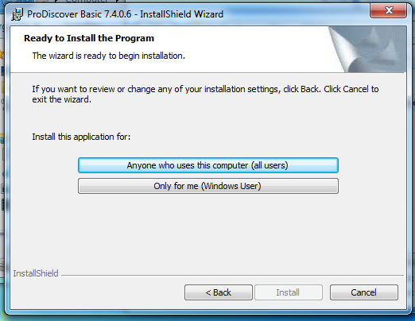
Downloading a Simple Test Image
In your Windows machine, in a Web browser, download this file:
http://samsclass.info/121/proj/nps-2009-canon2-gen6.dd
This is an image of a 32 MB SD card which has photographs on it. The file is 30 MB in size.
Save the file on your desktop.
Changing the Image Filename Extension
ProDiscover won't open the file unless you change its ".raw" filename extension to .dd
Click Start, Computer.
In the Computer window, click Organize, "Folder and Search Options".
In the "Folder Options" box, click the View tab.
Clear the "Hide extensions for known file types" box, as shown below:
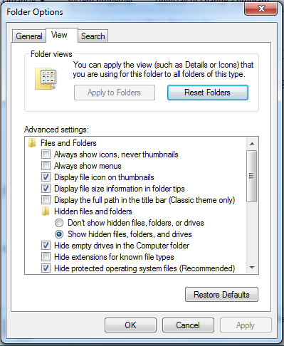
Click OK.
On your desktop, right-click the nps-2009-canon2-gen6.raw file and click Rename.
Change the file extension from ".raw" .dd, as shown below, and press the Enter key.
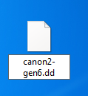
In the Rename box, click Yes.
Starting ProDiscover
On your desktop, double-click the "ProDiscover Basic" icon.
In the "Launch Dialog" box, enter a "Project Number" of 5 and a "Project File Name" of 5-YOURNAME, replacing "YOURNAME" with your own name, as shown, e.g. below:
Click Open.
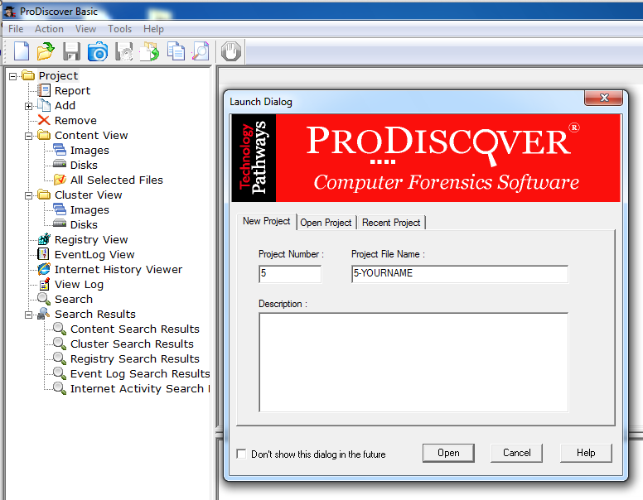
This creates a Project, but so far the Project has no evidence in it.
Adding an Image File
From the ProDiscover menu bar, click Action, Add, "Image File...", as shown, e.g. below.
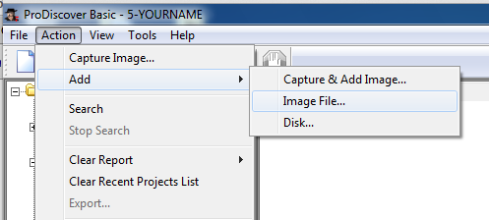
Navigate to your desktop and double-click the nps-2009-canon2-gen6.dd file.
Viewing the SD Card Image
In the left pane of ProDiscover, in the "Content View" section, click the plus sign to expand Images.
Expand C:\Users\student\Desktop\nps-2009-canon2-gen6.dd
Expand C:
Expand DCIM
Click 100CANON to select it.
A list of IMG files appears in the upper right pane, as shown, e.g. below.
Using ASCII View
In the upper right pane, click one of the IMG files to select it.
The lower right pane shows the contents of this file in ASCII, as shown below. This isn't a very useful way to view a photographic image, but it does show the EXIF metadata which shows the model of camera used, and the time the photograph was taken.
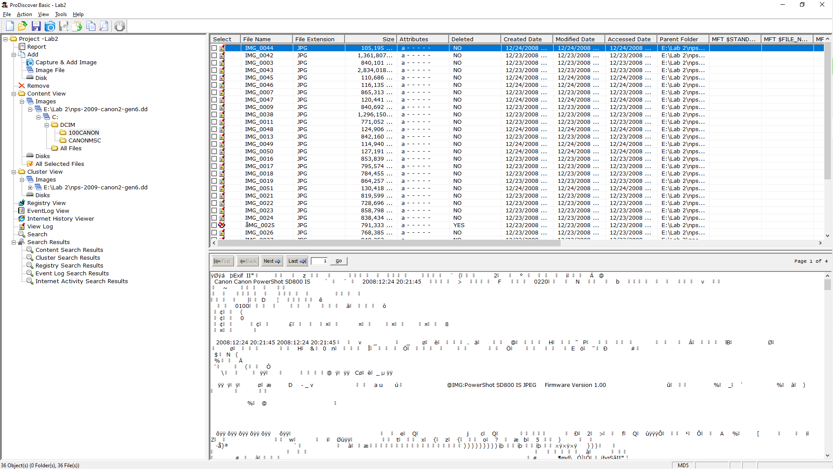
Using Photo Viewer
In the upper right pane, double-click one of the IMG files.
Now it opens in an image viewer so you can see the photograph, as shown, e.g. below.
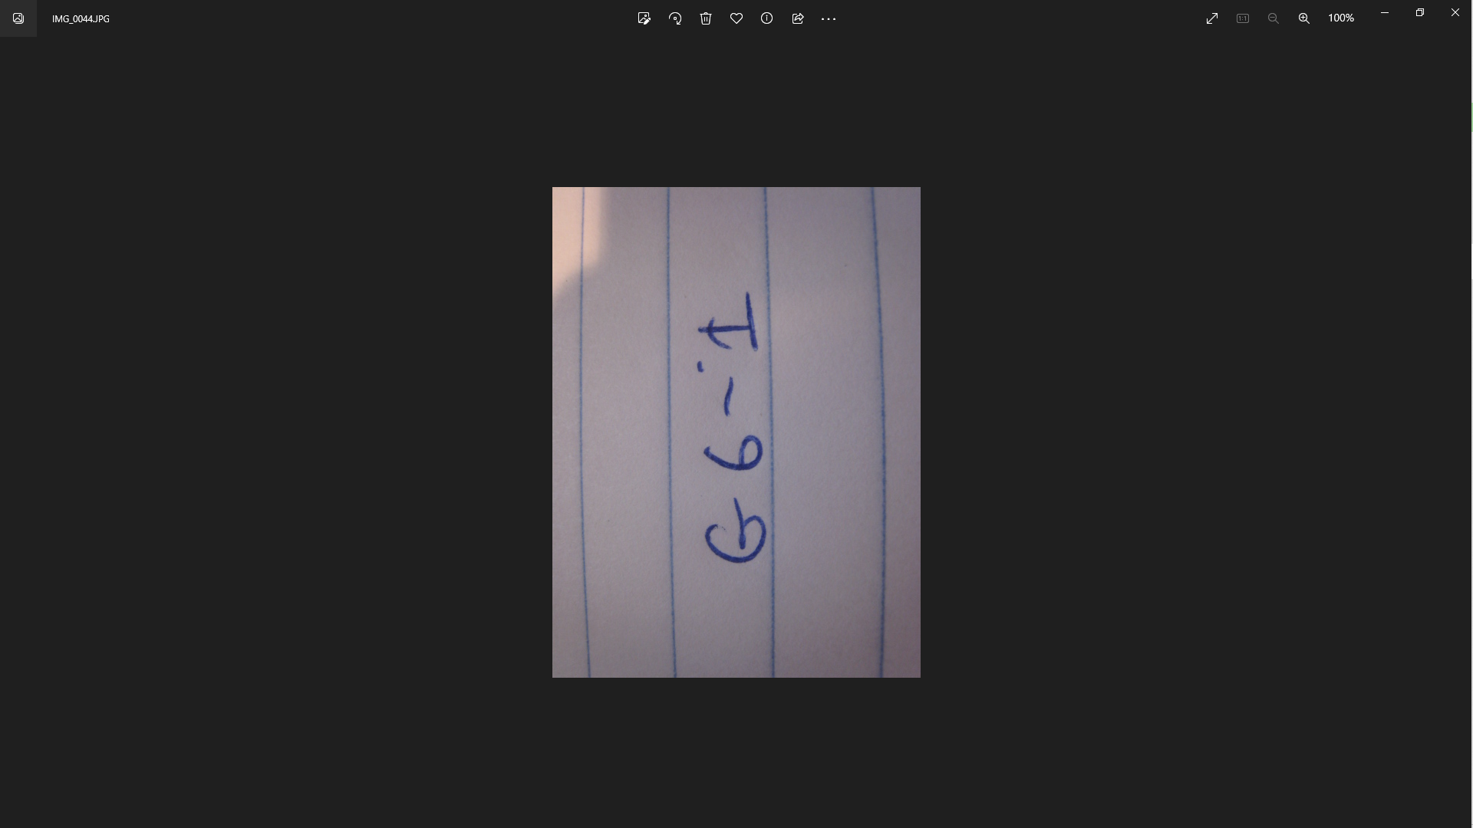
Close the "Windows Photo Viewer" window.
Viewing a Deleted Photograph
In the upper right pane of ProDiscover, scroll down till you find the image below IMG_0024.
Click the image to select it, as shown, e.g. below.
This is a deleted file, which has been recovered by ProDiscover. It's only partially recovered at this point, however. We'll do file carving in a later project.
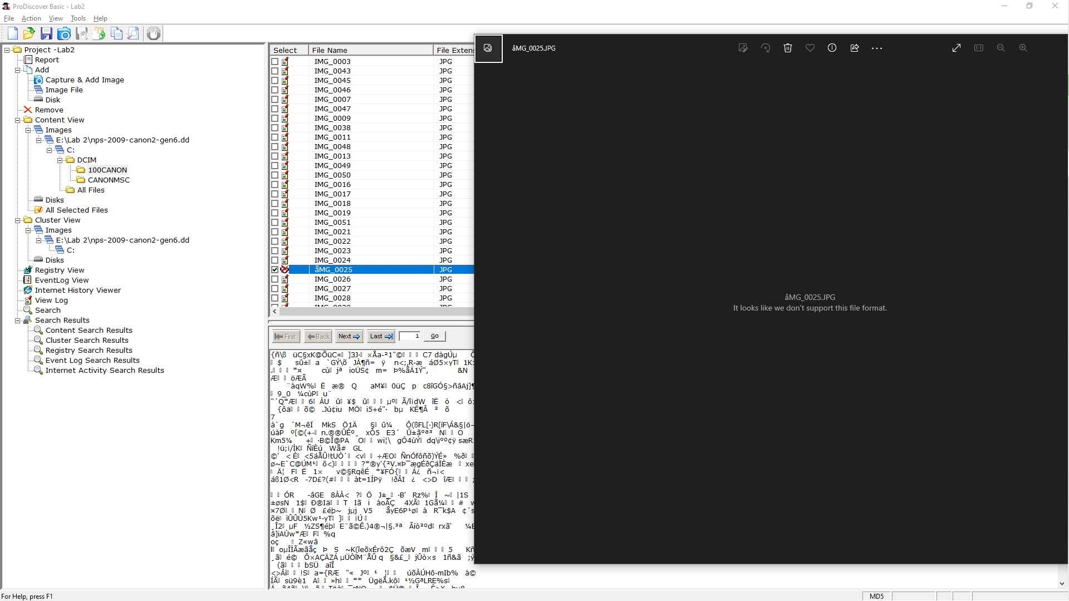
Saving a Screen Image
Make sure your screen shows a Deleted file (Deleted of "YES") and the contents of that file in the lower right, as shown above.
Press the PrintScrn key in the upper-right portion of the keyboard. That will copy the whole desktop to the clipboard.
YOU MUST SUBMIT A FULL-SCREEN IMAGE TO GET FULL CREDIT!
Open Paint and paste in the image.
Save the image with the filename "Your Name Lab 2". Use your real name, not the literal text "Your Name".
Saving Your ProDiscover Project
In ProDiscover, click File, "Save Project".
Save it on your desktop with the default filename, which should be 5-YOURNAME.dft
Close ProDiscover.
Turning in your Project
Email the image to me as an attachment to an e-mail message.
Send it to: xxx@fe.edu.vn with a subject line of "Lab 2 From Your Name", replacing "Your Name" with your own first and last name.
Send a Cc to yourself.

